Git assignment 1

TASK 1 – git commands

1. git init

* The command git init is used to create an empty Git repository.
* After the git init command is used, a .git folder is created in the directory with some subdirectories. Once the repository is initialized, the process of creating other files begins.



1. git status

* The git status command tells the current state of the repository.
* The command provides the current working branch. If the files are in the staging area, but not committed, it will be shown by the git status. Also, if there are no changes, it will show the message no changes to commit, working directory clean.

1. git branch

* It will list out the all the branch available in local machine

1. git pull

* This command is used to fetch and merge changes from the remote repository to the local repository.

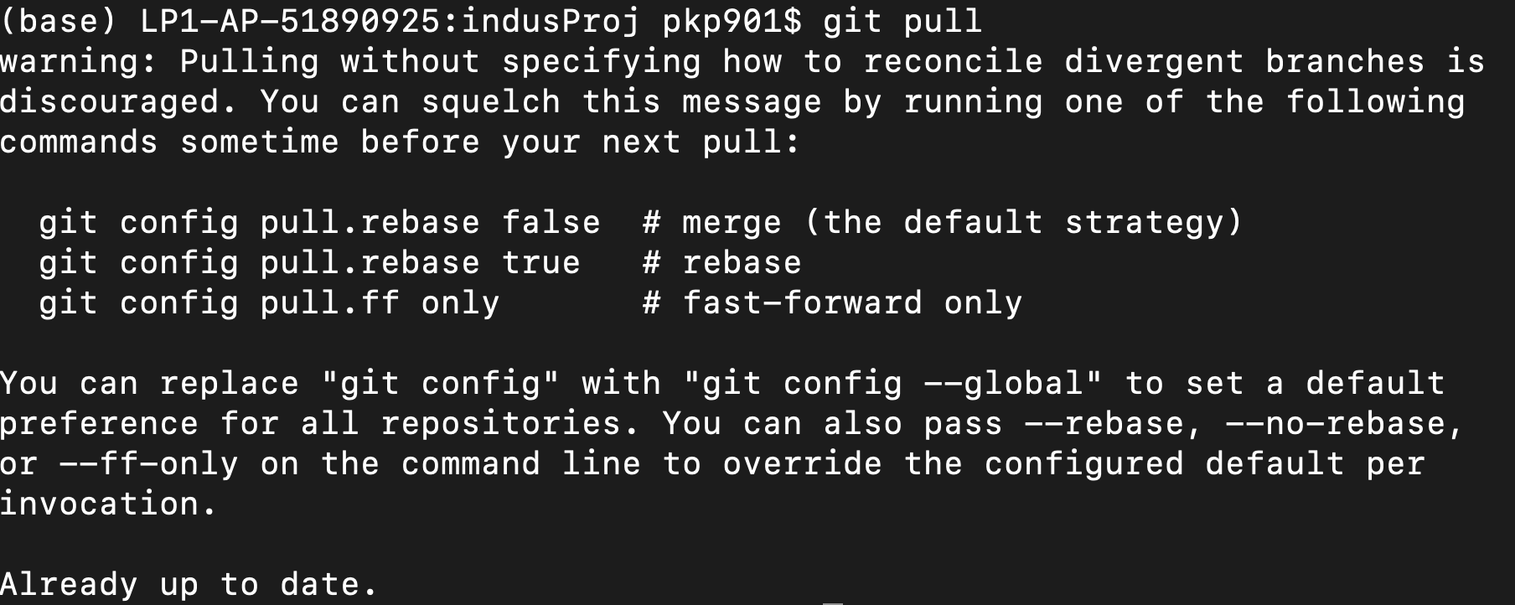

1. git pull -r

* This command is used to pull changes with rebase

1. git fetch

* This command used to download contents from a remote repository.

1. git log

it shows the order of the commit history for a repository.

1. git add .

it allow to add all new file/modified files



1. git add <file name>

it allow to add untracked files/modified files using the name of particular file.



1. git commit -m “commit message”

using this command a commit happens

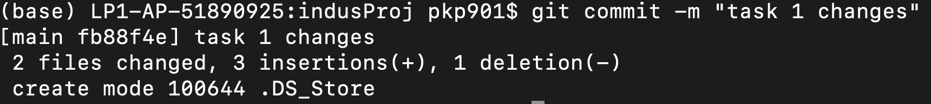

1. git push origin -main

this command is used to push committed change into the remote repository.

1. git branch <branch name>

this command will create a new branch

1. git branch -d <branch name>

this command will delete a given branch

1. git checkout <branch name>

this command will switch to the given branch

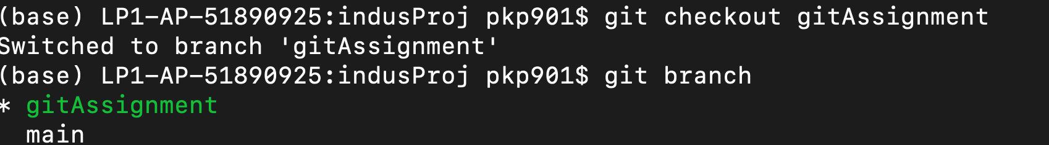

1. git checkout -b < new branch name>

this command will create a new branch as name given and switch to that branch

1. git reset –hard

this command will lead to previous commit removing all the latest changes.



1. git stash

this command will lead to previous commit removing all the latest changes.

